

Darshan University

A Project Report on

**“Textile business management system”**

Under the subject

**Software Engineering (2101CS503)**

B. Tech, Semester – V

Computer Science & Engineering Department

|  |  |
| --- | --- |
| Submitted By | |
| Student Name: Nirav G. Kagathara | Enrollment No.:22010101443 |
| Academic Year  (2024-2025) | |
| Internal Guide  Prof. Rajkumar B. Gondaliya  Darshan University | Dean-DIET  Dr. Gopi Sanghani  Darshan University |
|  |  |

|  |  |
| --- | --- |
|  | **Computer Science & Engineering Department**  **Darshan University** |

**DECLARATION**

We hereby declare that the SRS, submitted along with the **Software Engineering** **(2101CS503)** for entitled **“Textile Management System”** submitted in partial fulfilment for the Semester-5 of **Bachelor Technology (B. Tech)** in **Computer Science and Engineering (CSE)** Departmentto Darshan University, Rajkot, is a record of the work carried out at **Darshan University, Rajkot** under the supervision of **Prof. Rajkumar B. Gondaliya** and that no part of any of report has been directly copied from any students’ reports, without providing due reference.

Nirav G. Kagathara

Student’s Signature

Date: / /

|  |  |
| --- | --- |
|  | **Computer Science & Engineering Department**  **Darshan University** |

**CERTIFICATE**

This is to certify that the SRS on **“Textile management system” has** been satisfactorily prepared by **Nirav G. Kagathara** (**22010101443**) under my guidance in the fulfillment of the course **Software Engineering (2101CS503)** work during the academic year 2024-2025.

|  |  |  |
| --- | --- | --- |
| Internal Guide  Prof. Rajkumar B. Gondaliya  Darshan University |  | Dean-DIET  Dr. Gopi Sanghani  Darshan University |

**Acknowledgement**

I wish to express my sincere gratitude to my project guide **Prof. Rajkumar B. Gondaliya** and all the faculty members for helping me through my project by giving me the necessary suggestions and advices along with their valuable co- ordination in completing this work.

I also thank my parents, friends and all the members of the family for their precious support and encouragement which they had provided in completion of my work. In addition to that, I would also like to mention the Darshan University personals who gave me the permission to use and experience the valuable resources required for the project from the University premises.

Thus, in conclusion to the above said, I once again thank the faculties and members of **Darshan University** for their valuable support in completion of the project.

Thanking You

**Nirav G. Kagathara**

**ABSTRACT**

The Textile Business Management System is a comprehensive software solution aimed at optimizing operations and facilitating seamless communication between administrators and distributors within the textile industry. Textile Business Management System offers essential functionalities including user management, enabling user registration, login, profile management, and access control for both administrators and distributors. Administrators can efficiently oversee the product catalog, managing additions, modifications, and deletions, along with inventory and pricing management. Distributors can place orders, which administrators can review, approve, or reject, with real-time order tracking to ensure transparency. Secure payment processing for distributor orders is integrated, alongside automated invoice generation and distribution, coupled with payment status tracking and reminders. Robust reporting and analytics capabilities provide administrators with comprehensive sales and inventory insights, while distributors gain access to performance analytics and sales trends. A built-in in-app messaging system fosters efficient communication between all stakeholders, with notifications and alerts keeping users informed of critical updates. The system places a strong emphasis on security, implementing data encryption and user authentication measures to protect sensitive information.

**Table of Contents**

List of Figures I

List of Tables II

1 Introduction 3

1.1 Product perspective 3

1.2 Product features 3

1.2.1 There are two different users who will be using this product: 3

1.2.2 The features that are required for the Admin are: 3

1.2.3 The features that are required for the Distributors are: 3

1.3 Functional Requirement 4

1.3.1 Admin 4

1.3.2 Distributors 4

1.4 Non-Functional Requirement 5

1.4.1 Usability: 5

1.4.2 Availability: 5

1.4.3 Maintainability: 5

1.4.4 Error Handling: 5

1.4.5 Compatibility: 5

2 Design and Implementation Constraints 6

2.1 Use case diagram 6

2.2 Activity diagram and Swimlane diagram 7

2.2.1 Activity diagram 7

2.2.2 Swimlane diagram 8

2.3 Sequence diagram 9

2.4 State diagram 10

2.5 Class diagram 11

2.6 Data flow diagram 12

2.6.1 Context diagram (level-0) 12

2.6.2 DFD Level-1 13

2.6.3 DFD Level-2 14

3 External interface requirement (Screens) 15

3.1 Screen-1: Shipment & logistic 15

3.2 Screen-2: Payment screen 16

3.3 Screen-3: Delivery status screen 17

3.4 Screen-4: Change Password 18

3.5 Screen-5: Add New Customer 19

4 Database design 20

4.1 List of Tables 20

5 Stories and Scenario 24

5.1 Story-1: Admin Product management 24

5.1.1 Scenario# S1.1 24

5.1.2 Scenario# S1.2 24

5.1.3 Scenario# S1.3 24

5.1.4 Scenario# S1.4 25

5.2 Story-2: Admin Distributor management 25

5.2.1 Scenario# S2.1 25

5.2.2 Scenario# S2.2 25

5.2.3 Scenario# S2.3 26

6 Test cases 27

7 References 32

# List of Figures

Figure 2.1‑1 Use case diagram for textile business management system 6

Figure 2.2‑1 Activity diagram for textile business management system 7

Figure 2.2‑2 Swimlane diagram for textile business management system 8

Figure 2.3‑1 Sequence diagram for textile business management system 9

Figure 2.4‑1 State diagram of textile business management system 10

Figure 2.4‑2 State diagram-2 of textile business management system 10

Figure 2.5‑1 Class diagram for Textile management system 11

Figure 2.6‑1 Context diagram for Textile management system 12

Figure 2.6‑2 DFD level-1 for Textile management system 13

Figure 2.6‑3 DFD level-2 for Issue book 14

Figure 3.1‑1 Screen-1: shipment and logistic 15

Figure 3.2‑1 Screen-2: Payment screen 16

Figure 3.3‑1 Screen-3: Delivery status screen 17

# List of Tables

Table 3.1‑1 shipment and logistic 15

Table 3.2‑1 Screen element of Payment screen 16

Table 3.3‑1 Screen element of Delivery status screen 17

Table 4.1‑1 Table: Admin 20

Table 4.1‑2 Table: Distributer 20

Table 4.1‑3 Table: Product Type table 20

Table 4.1‑4 Table: Product Color 21

# Introduction

## Product perspective

The Textile Business Management System (TBMS) exists as an integral part of the textile business framework. It interfaces with external payment gateways to ensure secure transactions and may integrate with existing inventory management systems. TBMS provides user-friendly web interfaces accessible via standard web browsers. Hardware requirements are minimal, relying on standard computing equipment and internet connectivity.It maintains compatibility across various operating systems and web browsers to ensure broad accessibility.TBMS interacts with external systems for payment processing, email notifications, and data synchronization. Regulatory compliance is a priority, ensuring adherence to industry standards. Overall, TBMS seamlessly integrates with existing systems, prioritizing security and compliance to enhance operational efficiency.

## Product features

### There are two different users who will be using this product:

* Admin who will be acting as the administrator.
* Distributors who will be accessing the sytem.

### The features that are required for the Admin are:

* Admin should have the ability to create and manage user accounts, including distributor accounts, with access control and user profile management features.
* Administrators require comprehensive tools to manage the product catalog, including adding, editing, and removing products. They should also manage pricing and discounts.
* Admin need a workflow for reviewing and approving/rejecting distributor orders. This should include access to order details and the ability to modify or cancel orders if necessary.
* Inventory tracking features are essential, allowing administrators to monitor product availability, receive low-stock alerts, and manage restocking efficiently.
* Admins should be able to generate invoices for approved orders, manage invoice records, and handle any discrepancies or disputes.
* Detailed sales and inventory reports, along with analytics tools, are crucial for administrators to make informed decisions and plan inventory and pricing strategies
* Admins require in-app messaging capabilities to communicate with distributors, addressing, inquiries, providing support, and sharing important updates.

### The features that are required for the Distributors are:

* Distributors require access to the product catalog with up-to-date information on available products, including pricing and discounts
* Distributors need the ability to place orders for textile products easily, with a user-friendly order submission process.
* Real-time order status tracking features are essential, allowing distributors to monitor the progress of their orders from submission to delivery
* Secure payment processing capabilities should be available to facilitate payments for placed orders.

## Functional Requirement

### Admin

* **Distributors Management**: Admins should have the ability to create, modify, and delete distributors . Admins should be able to assign and manage user roles and permissions.
* **Product Catalog Management**: Admins should be able to add, edit, and delete products in the catalog. They should be able to set product attributes such as name, description, price, and availability. Admins should manage product categories and organize products accordingly.
* **Pricing and Discount Management**: Admins should be able to set and adjust product prices. They should have the capability to define and manage discounts, including seasonal promotions or bulk order discounts.
* **Order Review and Approval**: Admins should have access to a dashboard displaying incoming distributor orders. They should be able to review order details, including product quantities, prices, and distributor information. Admins should approve or reject distributor orders, with the ability to provide reasons for rejection if necessary.
* **Inventory Management**: Admins should be able to monitor real-time inventory levels for all products. Admins should initiate restocking processes and specify quantities to reorder.
* **Reporting and Analytics**: Admins should have access to sales reports, inventory reports, and performance analytics. Sales reports should include data on sales volumes, revenue, and profit margins over customizable time frames.Inventory reports should display current stock levels for all textile products.Performance analytics should provide insights into top-performing products, best-selling categories, and distributor sales trends.
* **Exporting and Sharing**: Admins should be able to export reports, analytics data, and other critical information

in common formats (e.g., CSV, PDF) for further analysis or sharing with stakeholders.

### Distributors

* **Product Catalog Access:** Distributors should have access to the complete product catalog, including details such as product names, descriptions, prices, and availability.
* **Order Placement:** Distributors should be able to place orders for textile products, specifying product quantities and delivery preferences.
* **Order Tracking :** Distributors should be able to track the status of their orders in real-time. Order statuses should include order received, order approved, order shipped, and order delivered.
* **Payment Processing:** Distributors should have the ability to make secure payments for their orders using various payment methods (e.g., credit card, bank transfer).
* **Profile Management:** Distributors should be able to update their profile information, including contact details and business information.
* **Order History and Records:** Distributors should have access to their order history and records

enabling them to view past orders, invoices, and payment receipts.

## Non-Functional Requirement

### Usability:

* The user interface should be intuitive and user-friendly, requiring minimal training for distributors to

navigate and place orders efficiently.

### Availability:

* The system should be available 24/7, with a targeted uptime of 99.9%, ensuring that distributors can

access and use it at any time.

### Maintainability:

* The software should be easily maintainable and adding new features and making changes to the software

must be as simple as possible. In addition to this, the software must also be portable.

### Error Handling:

* The system should provide clear and user-friendly error messages to distributors in case of any

issues, helping them understand the problem and how to resolve it.

### Compatibility:

* The system should be compatible with a wide range of web browsers and devices

(e.g., desktops, tablets, smartphones) to accommodate the diverse preferences of distributors.

# Design and Implementation Constraints

## Use case diagram

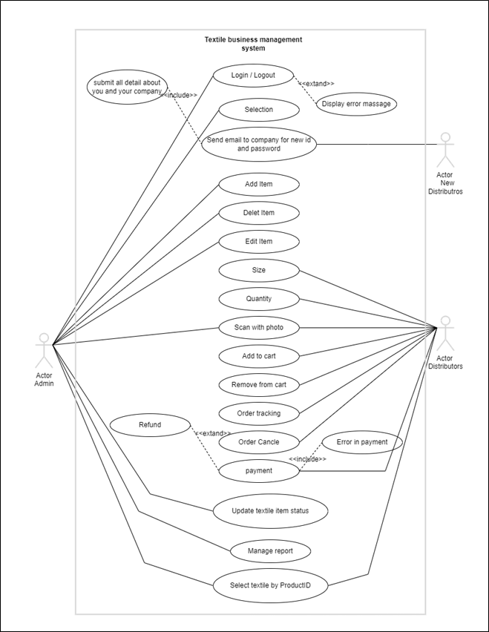

Figure ‑ Use case diagram for textile business management system

## Activity diagram and Swimlane diagram

### Activity diagram

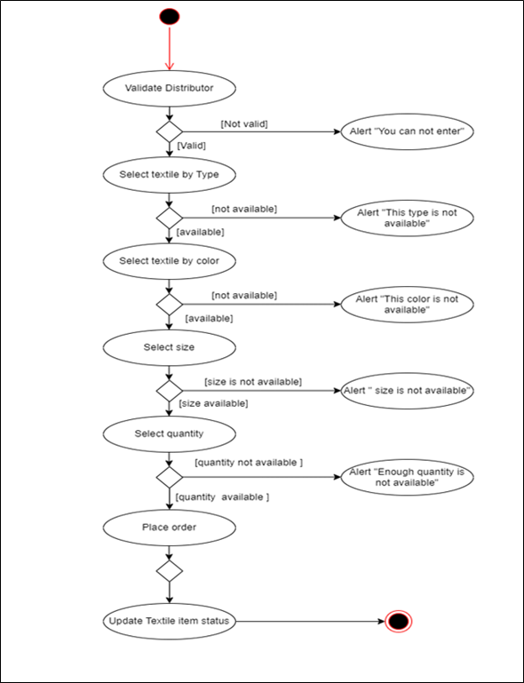

Figure ‑ Activity diagram for textile business management system

### Swimlane diagram

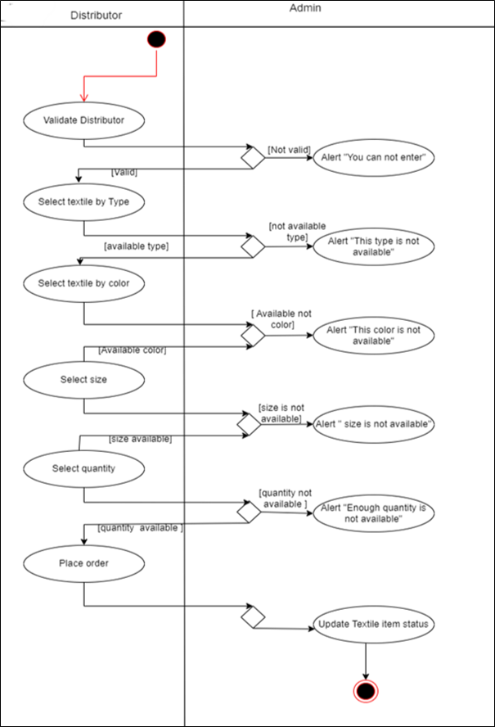

Figure ‑ Swimlane diagram for textile business management system

## Sequence diagram

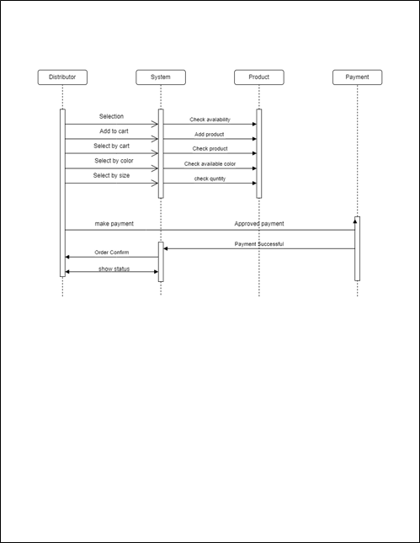

Figure ‑ Sequence diagram for textile business management system

## State diagram

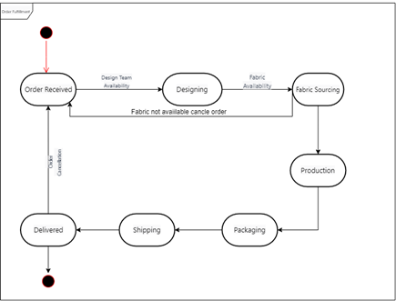

Figure ‑ State diagram of textile business management system

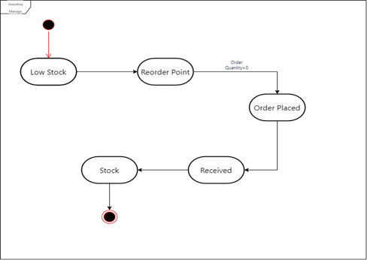

Figure ‑ State diagram-2 of textile business management system

## Class diagram

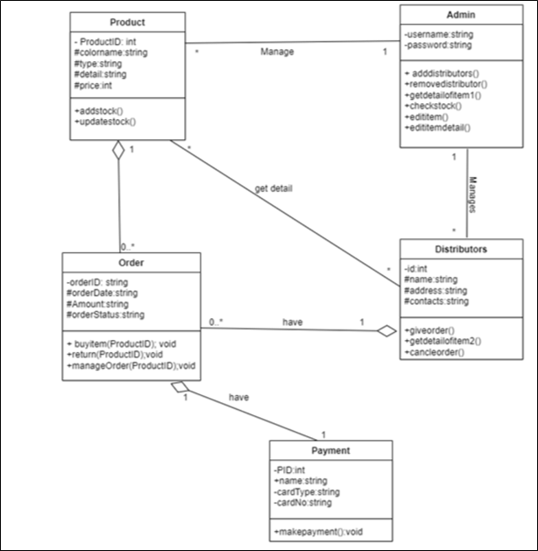

Figure ‑ Class diagram for Textile management system

## Data flow diagram

### Context diagram (level-0)

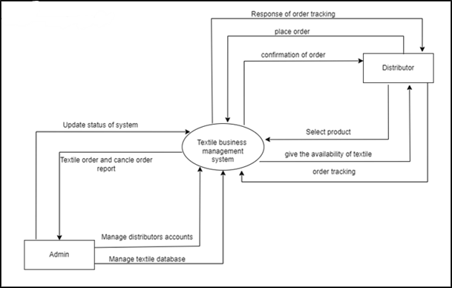

Figure ‑ Context diagram for Textile management system

### DFD Level-1

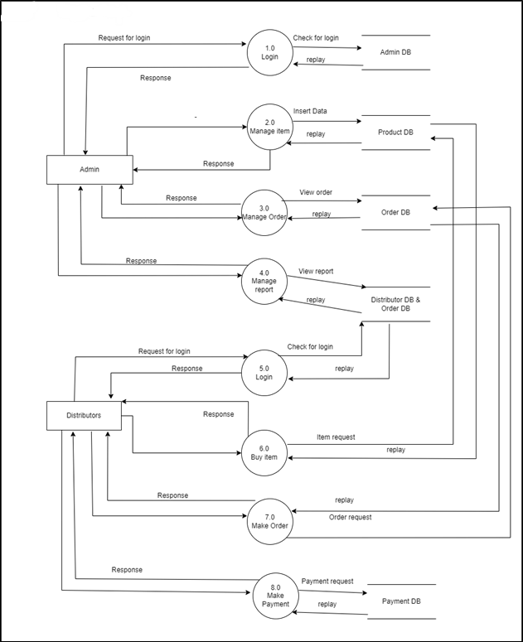

Figure ‑ DFD level-1 for Textile management system

### DFD Level-2

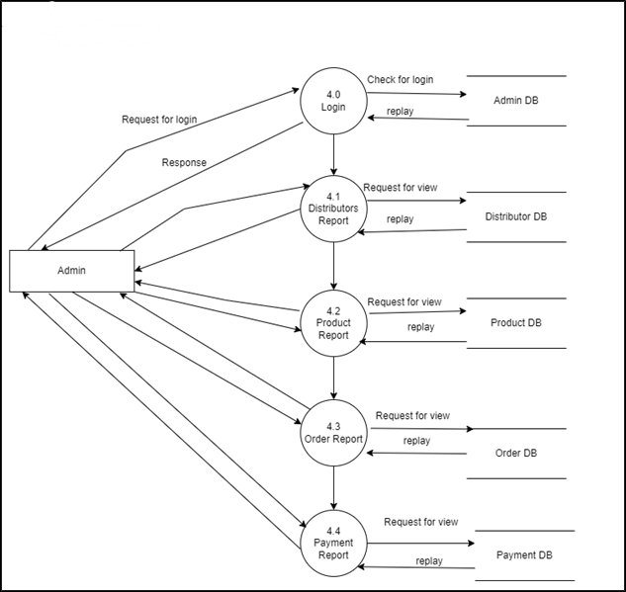

Figure ‑ DFD level-2 for Issue book

# External interface requirement (Screens)

## Screen-1: Shipment & logistic

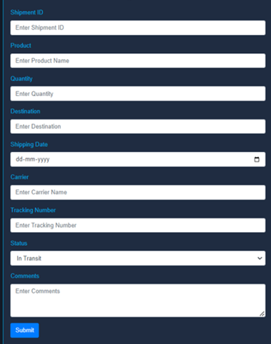

Figure ‑ Screen-1: shipment and logistic

**Purpose:** This module will allow the system administrator or staff to enter the shipment details of any orderwhich

will be further helpful for the customer for tracking their order details.

Table ‑ shipment and logistic

|  |  |  |  |  |  |
| --- | --- | --- | --- | --- | --- |
| **Sr.** | **Screen Element** | **Input Type** | **O/M** | **1/N** | **Description** |
| **1** | Shipment ID | Textbox | M | 1 | Shipment ID field should be editable and fill  autogenerated Shipment ID. |
| **2** | Product | Textbox | M | M | It takes product name as input from user. |
| **3** | Quantity | Textbox | M | N | It takes product quantity name as input from user. |
| **4** | Destination | Textbox | O | 1 | It takes product destination name as input from user. |
| **5** | Shipping Date | Textbox | M | 1 | It takes product shipping date as input from user. |
| **6** | Carrier | Textbox | M | 1 | It takes product carrier name as input from user. |
| **7** | Tracking Number | Textbox | M | 1 | It takes product Tracking number name as input from user. |
| **8** | Status | Button | M | 1 | It takes product Status as input from user |
| **9** | Comments | Button | O | ----- | If user want to enter any comment user can enter here in comment box. |
| **10** | Submit | Button | ----- | ----- | Submit is a button used to submit shipment details |

## Screen-2: Payment screen

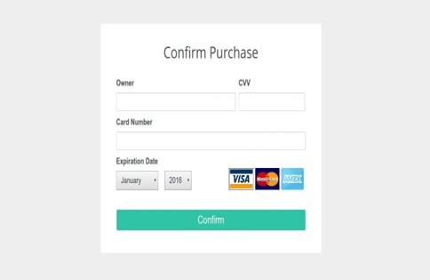

Figure ‑ Screen-2: Payment screen

**Purpose:** This module will allow the system administrator to add, edit, update or delete borrowers of book. The

admin can add borrower information and manage it.

Table ‑ Screen element of Payment screen

|  |  |  |  |  |  |
| --- | --- | --- | --- | --- | --- |
| **Sr.** | **Screen Element** | **Input Type** | **O/M** | **1/N** | **Description** |
| **1** | Owner | Textbox | M | 1 | Name field should be editable and accept the  name which is credit/debit card |
| **2** | Card Number | Textbox | M | 1 | This field should be editable and accept number  As per credit/debit card |
| **3** | CVV | Int | M | 1 | This field should be editable and accept 3 digit as  per credit/debit card |
| **4** | Expiration date | Date | M | 1 | It should be editable.and select date |
| **5** | Confirmation | Button | M | 1 | Your amount will pay after click this |

## Screen-3: Delivery status screen

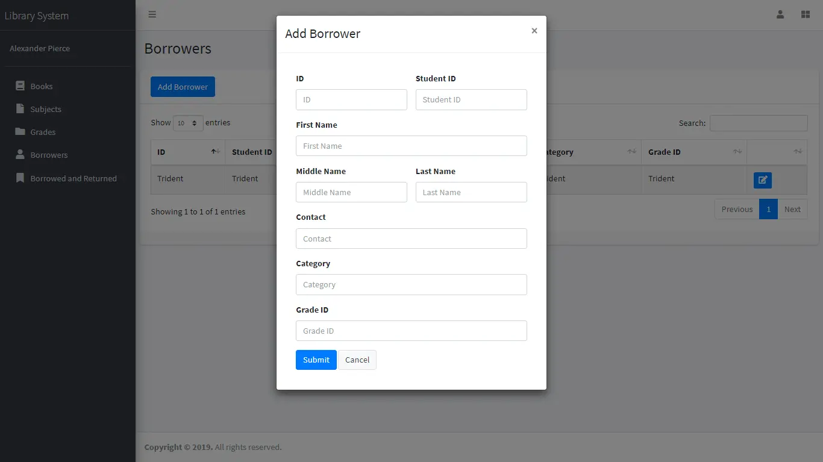

Figure ‑ Screen-3: Delivery status screen

**Purpose:** This Module show dilvery status in modual shaow all order detail about the order.

Table ‑ Screen element of Delivery status screen

|  |  |  |  |  |  |
| --- | --- | --- | --- | --- | --- |
| **Sr.** | **Screen Element** | **Input Type** | **O/M** | **1/N** | **Description** |
| **1** | ShipmentID | Int | M | 1 | Display ShipmentID on the top of screen. |
| **2** | Arrival Date | Date | M | 1 | Display date of arrival. |
| **3** | From | Textbox | M | 1 | Its display the starting place where order  packed. |
| **4** | To | Textbox | M | 1 | Its display destination city of order. |
| **5** | Recipient | Textbox | M | 1 | Display the name of distributors |

## Screen-4: Change Password

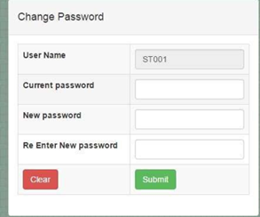

Figure 3.4-1 screen-4: Delivery status screen

**Purpose:** This module will allow to user change password of user account.

Table 3.4-1 Screen element of change password

|  |  |  |  |  |  |
| --- | --- | --- | --- | --- | --- |
| **Sr.** | **Screen Element** | **Input Type** | **O/M** | **1/N** | **Description** |
| **1** | Username | Textbox | M | 1 | Enter username . |
| **2** | Current password | Textbox | M | 1 | Enter current Password. |
| **3** | New Password | Textbox | M | 1 | Enter new Password. |
| **4** | Re-enter New password | Textbox | M | 1 | Re-enter new Password |
| **5** | clear | Button | -- | -- | Clear button use to in form clear all enterd detail. |
| **6** | submit | Button | -- | -- | Submit button is work change passow and update database. |

## Screen-5: Add New Customer

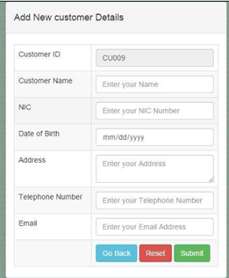

Figure 3.5-1 Screen-5: Add New Customer Details

**Purpose:** This module will add new customer deatis in databse.

Table 3.4-1 Screen element of Add new Customer screen

|  |  |  |  |  |  |
| --- | --- | --- | --- | --- | --- |
| **Sr.** | **Screen Element** | **Input Type** | **O/M** | **1/N** | **Description** |
| **1** | Customer Id | int | M | 1 | Enter Customer ID in form fild. |
| **2** | Customer Name | Textbox | M | 1 | Enter Customer name. |
| **3** | NIC | int | M | 1 | Enter new Password. |
| **4** | Date of Birth | Date | M | 1 | It should be editable.and select date and add customer bith Date. |
| **5** | Address | TextBox | M | 1 | Customer address will add in this form fild and customer change address. |
| **6** | Telephone Number | int | M | 1 | In this form fild customer phone number add. |
| **7** | Email | TextBox | O | 1 | Enter Customer Email this form fild is optional. |
| **8** | OnBack | Button | -- | -- | On Back button this button work is go back to redirect to previous screen. |
| **9** | Rest | Button | -- | -- | Reset button will rest a form fild if customer fill all details add wrong then change reset this form. |
| **10** | Submit | Button | -- | -- | Submit button will add all details add in database and store data. |

# Database design

## List of Tables

* Admin
* Distributors
* Product Types Table
* Product Colors Table
* Products Table
* Stock Table
* Transactions Table
* Orders Table
* OrderDetails Table
* OrderAmount Table

Table ‑ Table: Admin

|  |  |  |  |  |
| --- | --- | --- | --- | --- |
| **Field Name** | **Datatype** | **Null** | **Constraint** | **Description** |
| AdminID | Int | Not Null | Primary Key | Auto Increment |
| Username | Varchar(50) | Not Null | - | - |
| Password | Int | Not Null | - | - |
| Name | Varchar(50) | Not Null | - | - |
| Email | Int | Not Null | - | - |
| PhoneNumber | Int | Not Null | - | - |
| Description | Varchar(100) | Allow Null | - | - |

Table ‑ Table: Distributer

|  |  |  |  |  |
| --- | --- | --- | --- | --- |
| **Field Name** | **Datatype** | **Null** | **Constraint** | **Description** |
| DistributorID | Int | Not Null | Primary Key | Auto Increment |
| CompanyName | Varchar(30) | Not Null | - | - |
| ContactPersonName | Varchar(25) | Allow Null | - | - |
| Address | Varchar(30) | Allow Null | - | - |
| Email | Varchar(30) | Allow Null |  |  |
| PhoneNumber | Int | Not Null |  |  |
| Description | Varchar(100) | Allow Null |  |  |
|  |  |  |  |  |

Table ‑ Table: Product Type table

|  |  |  |  |  |
| --- | --- | --- | --- | --- |
| **Field Name** | **Datatype** | **Null** | **Constraint** | **Description** |
| TypeID | Int | Not Null | Primary Key | Auto Increment |
| TypeName | Int | Not Null | - | - |
| Description | Varchar(100) | Allow Null | - | - |
|  |  |  |  |  |

Table ‑ Table: Product Color

|  |  |  |  |  |
| --- | --- | --- | --- | --- |
| **Field Name** | **Datatype** | **Null** | **Constraint** | **Description** |
| ColorID | Int | Not Null | Primary Key | Auto Increment |
| ColorName | Varchar(50) | Not Null | - | - |
| HexCode | Varchar(7) | Not Null | - | - |
| RGBValues | Varchar(15) | Not Null | - | - |
| Description | Varchar(100) | Allow Null |  |  |

Table ‑5 Table: Product

|  |  |  |  |  |
| --- | --- | --- | --- | --- |
| **Field Name** | **Datatype** | **Null** | **Constraint** | **Description** |
| ProductID | Int | Not Null | Primary Key | Auto Increment |
| ProductName | Varchar(20) | Not Null | - | - |
| TypeID | Int | Not Null | Foreign Key | Reference of Products Type table |
| ColorID | Int | Not Null | Foreign Key | Reference of Product Colors table |
| Price | Int | Not Null | - | - |
| Description | Varchar(100) | Allow Null | - | - |
|  |  |  |  |  |

Table ‑5 Table: Stock

|  |  |  |  |  |
| --- | --- | --- | --- | --- |
| **Field Name** | **Datatype** | **Null** | **Constraint** | **Description** |
| StockID | Int | Not Null | Primary Key | Auto Increment |
| ProductID | Int | Not Null | ForeignKey | Reference of Products table |
| DistributorID | Int | Not Null | Foreign Key | Reference of Distributors  table |
| Quantity | Int | Not Null | - | Quantity of the product |
| in stock. |
| PurchaseDate | DateTime | Not Null | - | - |
| ExpiryDate | DateTime | Not Null | -. | - |
| Description | Varchar(100) | Allow Null |  |  |

Table ‑6 Table: Transaction

|  |  |  |  |  |
| --- | --- | --- | --- | --- |
| **Field Name** | **Datatype** | **Null** | **Constrai nt** | **Description** |
| TransactionID | Int | Not Null | Primary Key | Auto Increment |
| DistributorID | Int | Not Null | ForeignKey | Reference of Distributors  table |
| AdminID | Int | Not Null | Foreign Key | Reference of Admin table |
| ProductID | Int | Not Null | Foreign Key | Reference of Products table |
| Quantity | Int | Not Null | - | Quantity of products  involved in the |
| transaction. |
| TransactionDate | DateTime | Not Null | - | - |
| Description | Varchar(100) | Allow Null | - | - |

Table ‑7 Table: order

|  |  |  |  |  |
| --- | --- | --- | --- | --- |
| **Field Name** | **Datatype** | **Null** | **Constraint** | **Description** |
| OrderID | Int | Not Null | Primary Key | Auto Increment |
| DistributorID | Int | Not Null | Foreign Key | Reference of  Distributors table |
| AdminID | Int | Not Null | Foreign Key | Reference of Admin  table |
| OrderDate | Int | Not Null | - | - |
| Description | Varchar(100) | Allow Null | - | - |
|  |  |  |  |  |

Table ‑8 Table: orderdetails

|  |  |  |  |  |  |
| --- | --- | --- | --- | --- | --- |
| **Field Name** | | **Datatype** | **Null** | **Constraint** | **Description** |
| OrderDetailID |  | Int | Not Null | Primary Key | Auto Increment |
| OrderID | | Int | Not Null | Foreign Key | Reference of Orders table |
| ProductID | | Int | Not Null | Foreign Key | Reference of Products  table |
| Quantity | | Int | Not Null | - | Quantity of the product in the order. |
| Description | | Varchar(100) | Allow Null | - | - |

Table ‑9 Table: orderamount

|  |  |  |  |  |
| --- | --- | --- | --- | --- |
| **Field Name** | **Datatype** | **Null** | **Constraint** | **Description** |
| OrderAmountID | Int | Not Null | Primary Key | Auto Increment |
| OrderID | Int | Not Null | Foreign Key | Reference of Orders  table |
| Amount | Int | Not Null | - | - |
| Description | Varchar(100) | Allow Null | - | - |

# Stories and Scenario

## Story-1: Admin Product management

|  |  |  |
| --- | --- | --- |
| *Story #* ***S1*** | : | As an admin, I want to add new textile products to the system with details like name, description, price, and available quantity. |
| **Priority** | **:** | High |
| **Estimate** | **:** | XL |
| **Reason** | **:** | Admin needs to manage the product catalog, a core function of the system. |

### Scenario# S1.1

|  |  |  |  |  |
| --- | --- | --- | --- | --- |
| *Scenario#* ***S1.1*** |  | **:** | Adding a New Product |  |
| **Prerequisite**  **__Acceptance ______Criteria** |  | **:**  **:** | The admin logs into the system, navigates to the product management section, and selects the option to add a new product. They provide details such as the product name, description, price, and available quantity. Upon submission, the system stores the new product's information in the product  database, making it available for distributors to order. | |

### Scenario# S1.2

|  |  |  |  |  |
| --- | --- | --- | --- | --- |
| *Scenario#* ***S1.2*** | **:** | Updating Product Information |  | |
| **Prerequisite** | **:** | As an admin, I want to update the details of an existing textile product. | |  |
| **Acceptance Criteria** | **:** | The admin logs into the system, accesses the product management section, and searches for the product whose information needs updating. The admin selects the product and edits the relevant details, such as the product's price, description, or available quantity. Upon saving the changes, the system updates the product information in the database, ensuring it's  accurate for distributors. | | |

### Scenario# S1.3

|  |  |  |  |
| --- | --- | --- | --- |
| *Scenario#* ***S1.3*** | **:** | Deleting a Product |  |
| **Prerequisite** | **:** | As an admin, I want to be able to remove a textile product from the system. | |
| **Acceptance Criteria** | **:** | The admin logs into the system, goes to the product management section, and locates the product they wish to remove. The admin selects the product and chooses the option to delete it. The system removes the product's  information from the database, effectively making it unavailable for future orders from distributors. | |

### Scenario# S1.4

|  |  |  |  |
| --- | --- | --- | --- |
| *Scenario#* ***S1.4*** | **:** | Viewing Product Inventory |  |
| **Prerequisite** | **:** | As an admin, I want to view the current inventory status of all textile  products. | |
| **Acceptance Criteria** | **:** | The admin logs into the system, accesses the product management section, and selects the option to view the product inventory. The system displays a list of all textile products along with their current available quantities. This scenario helps the admin monitor product stock levels and make informed  decisions regarding restocking or discontinuing products. | |

## Story-2: Admin Distributor management

|  |  |  |
| --- | --- | --- |
| *Story #* ***S2*** | **:** | As an admin, I want to manage distributor information, including adding new distributors and updating their contact details. |
| **Priority** | **:** | High |
| **Estimate** | **:** | Xl |
| **Reason** | **:** | Admin must manage distributor information, a critical aspect of the system's  operation. |

### Scenario# S2.1

|  |  |  |  |  |
| --- | --- | --- | --- | --- |
| *Scenario#* ***S2.1*** | | **:** | Adding a New Distributor | |
| **Prerequisite** | | **:** | As an admin, I want to be able to add a new distributor to the system. | |
| **Acceptance Criteria** | **:** | |  | The admin logs into the system, navigates to the distributor management section, and selects the option to add a new distributor. They fill in the required information for the new distributor, such as name, contact details, and territory. Upon submission, the system  stores the new distributor's information in the database, making them an active user of the system. | |

### Scenario# S2.2

|  |  |  |  |
| --- | --- | --- | --- |
| *Scenario#* ***S2.2*** | **:** | Updating Distributor Contact Information. |  |
| **Prerequisite** | **:** | As an admin, I want to update the contact information of an existing distributor. | |
| **Acceptance Criteria** | **:** | The admin logs into the system, accesses the distributor management section, and searches for the distributor whose contact information needs updating. The admin selects the distributor and edits the relevant contact details, such as phone number or address. Upon saving the changes, the  system updates the distributor's contact information in the database. | |

### Scenario# S2.3

|  |  |  |  |
| --- | --- | --- | --- |
| *Scenario#* ***S2.3*** | **:** | Deactivating a Distributor |  |
| **Prerequisite** | **:** | As an admin, I want to be able to deactivate or suspend a distributor's  account. | |
| **Acceptance Criteria** | **:** | The admin logs into the system, goes to the distributor management section, and locates the distributor they wish to deactivate. The admin selects the distributor and chooses the option to deactivate the account. The system updates the distributor's status to "deactivated" in the database, preventing them from placing new orders or making changes to their  account. The distributor's order history and data remain accessible but are not modifiable while the account is deactivated. | |

# Test cases

|  |  |  |  |
| --- | --- | --- | --- |
| Project Name: | Textile Business Management System | Test Designed by: | Nirav Patel |
| Module Name: | **Product Management** | **Test Designed date:** | 9-9-2024 |
| Release Version: | **1.0** | **Test Executed by:** | **Nirav Patel** |
|  |  | **Test Execution date:** | 15-09-2024 |

|  |  |  |  |  |
| --- | --- | --- | --- | --- |
| Pre-condition: Web application should be accessible | | | | |
| Test Case ID | **Test Title** | **Test Type** | **Description** | **Test Case ID** |
| TC_001 | Product manage to web application with valid credential | Functional | Login to textile management system web application through valid credential | TC_001 |
| TC_002 | Order manage to web application with valid credential | Functional | Login to textile management system web application through valid credential | TC_002 |
| TC_003 | Verify the textile page element | GUI | varify that all elements are availabe on textile page | TC_003 |
| TC_004 | Product manage to web application with invalid credential | Functional | Login to textile management system web application through invalid credential | TC_004 |

|  |  |
| --- | --- |
| **Test Case Title** | Product manage to web application with valid credential |
| **Test Type** | Functional |
| **Test Priority** | High |
| **Pre-condition** | Web application should be accessible |

|  |  |  |  |  |  |  |  |
| --- | --- | --- | --- | --- | --- | --- | --- |
| **Test Step** | **Test Case Description** | **Expected Result** | **Actual Result** | **Status** | **Comment** | **Data** | **BUG ID** |
| 1 | Add a new item | Product added successfully | Display add product name | Pass |  | Product name:Lynn, Price:1000, size :1 meter |  |
| 2 | Update Product Information | Product information (e.g., price) is updated | Product information updated successfully | Pass |  | Product Name: Lynn, New Price:  950 |  |
| 3 | View Product Details | Product details are displayed correctly | Product details displayed correctly | Pass |  | Product Name:lynn |  |
| 4 | List All Products | All products in the inventory are listed | All products listed correctly | Pass | Display All Product List |  |  |
| 5 | Delete a Product | Product is removed from the inventory | Product deleted successfully | Pass |  | Product Name: Cotton, |  |

|  |  |
| --- | --- |
| **Test Case Title** | Order manage to web application with valid credential |
| **Test Type** | Functional |
| **Test Priority** | High |
| **Pre-condition** | Web application should be accessible |

|  |  |  |  |  |  |  |  |
| --- | --- | --- | --- | --- | --- | --- | --- |
| **Test Step** | **Test Case Description** | **Expected Result** | **Actual Result** | **Status** | **Comment** | **Data** | **Bug ID** |
| 1 | Create a New Distributor Order | New order is created successfully | Order created  successfully | Pass |  | Distributer: Vsk , |  |
| 2 | View Order Details | Clicking on an order displays its  details | Order details displayed  correctly | Pass |  | Order ID: 123 |  |
| 3 | Edit Order Details | Order details (e.g., quantity) are  updated | Order details updated  successfully | Pass |  | Order ID: 123, New  Quantity: 10 |  |
| 4 | Cancel an Order | Order is canceled successfully | Order canceled  successfully | Pass |  | Order ID: 124 |  |
| 5 | Process Payment | Payment for an order is recorded successfully | Payment recorded successfully | Pass |  | Order ID: 125,  Payment Amount: 20020.00 |  |
| 6 | Generate Invoice | An invoice for an order is generated | Invoice generated  successfully | Pass |  | Order ID: 126 |  |
| 7 | View Order History | List of orders is displayed correctly | Order history displayed  correctly | Pass |  |  |  |

|  |  |
| --- | --- |
| **Test Case Title** | Order manage to web application with valid credential |
| **Test Type** | Functional |
| **Test Priority** | High |
| **Pre-condition** | Web application should be accessible |

|  |  |  |  |  |  |  |  |
| --- | --- | --- | --- | --- | --- | --- | --- |
| **Test Step** | **Test Case Description** | **Expected Result** | **Actual Result** | **Status** | **Comment** | **Data** | **Bug ID** |
| 1 | Create a New Distributor Order | New order is created successfully | Order created  successfully | Pass |  | Distributer: Vsk , |  |
| 2 | View Order Details | Clicking on an order displays its  details | Order details displayed  correctly | Pass |  | Order ID: 123 |  |
| 3 | Edit Order Details | Order details (e.g., quantity) are  updated | Order details updated  successfully | Pass |  | Order ID: 123, New  Quantity: 10 |  |
| 4 | Cancel an Order | Order is canceled successfully | Order canceled  successfully | Pass |  | Order ID: 124 |  |
| 5 | Process Payment | Payment for an order is recorded successfully | Payment recorded successfully | Pass |  | Order ID: 125,  Payment Amount: 20020.00 |  |
| 6 | Generate Invoice | An invoice for an order is generated | Invoice generated  successfully | Pass |  | Order ID: 126 |  |
| 7 | View Order History | List of orders is displayed correctly | Order history displayed  correctly | Pass |  |  |  |

|  |  |
| --- | --- |
| **Test Case Title** | Verify textile page management |
| **Test Type** | GUI |
| **Test Priority** | Medium |
| **Pre-condition** | Web application should be accessible |

|  |  |  |  |  |  |  |  |
| --- | --- | --- | --- | --- | --- | --- | --- |
| **Test Step** | **Test Case Description** | **Expected Result** | **Actual Result** | **Status** | **Comment** | **Data** | **Bug ID** |
| 1 | Access Product Management Page | Clicking the "Product Management" link  navigates to the product management page | Page navigated successfully | Pass |  |  |  |
| 2 | View Product List | The product list is displayed with relevant details | Product list displayed correctly | Pass |  |  |  |
| 3 | Verify Product Table Columns | All necessary columns (e.g., Name, Price, Quantity) are visible | Columns displayed correctly | Pass |  |  |  |
| 4 | View Product Details | Clicking on a product displays its details | Product details displayed correctly | Pass |  | Product Name:  Aspirin |  |
| 5 | Add New Product Button | The "Add New Product" button is present and clickable | Button present and clickable | Pass |  |  |  |
| 6 | Edit Product Button | The "Edit" button for each product is present and clickable | Button present and clickable | Pass |  |  |  |
| 7 | Delete Product Button | The "Delete" button for each product is present and clickable | Button present and clickable | Pass |  |  |  |

# References

* [https://www.geeksforgeeks.org](https://www.geeksforgeeks.org/)
* [https://textilelearner.net](https://textilelearner.net/)
* <https://en.wikipedia.org/wiki/Textile_industry>
* <https://chat.openai.com/>